CHAPTER 1
Optimising Recency-Weighted Cycle Forecasting and Confidence Calibration in SheSync, a Mobile Menstrual Health Application
Sadhana Singh, Vyom Varshney*, Vishal Gupta, Shivangi Yadav, Vanshika Singh
Department of Computer Science and Engineering (Artificial Intelligence), ABES Institute of Technology, Ghaziabad, Uttar Pradesh, India, Email Id-vyomvarshney2005@gmail.com
Abstract: Period-tracking applications forecast the next period from a few past cycle lengths, yet the forecasting rule and the confidence they display are rarely validated. This chapter treats the forecasting engine of SheSync, a cross-platform React Native application built by the authors, as an optimisation problem. The deployed engine combines a recency-weighted mean of up to four cycles with hard floors taken from an intake questionnaire and shows a heuristic confidence. A Python re-implementation, which matched the shipped TypeScript function in all 14,400 test cases, was evaluated on 1,000 simulated users in three cohorts based on published app data, under stationary and drifting regimes. An exhaustive search over 6,561 weight vectors, a tuned shrinkage prior in place of the floors and a binned recalibration of the confidence were fitted on half of the users and tested on the other half. They lowered the mean absolute error from 4.20 to 3.69 days (12.0%) for stationary cycles, from 3.94 to 3.58 days (9.1%) under drift and by 20.3% with one past cycle, and cut the expected calibration error from 31.6 to 3.6 points. Re-tuning the weights alone changed the error by at most 1.2%; the questionnaire floors were the main avoidable error, and recency weighting paid off only when cycle means drifted.
Keywords: Menstrual cycle forecasting, Recency weighting, Grid search, Shrinkage estimation, Confidence calibration, Mobile health.
INTRODUCTION
The predicted start of the next period is usually the first number a period-tracker user looks at [1, 2]. Large app datasets show that the textbook 28-day cycle is the exception: across more than 600,000 cycles the mean length was 29.3 days and only about 13% of cycles lasted exactly 28 days [3], over half of the users of a connected ovulation test had cycles that varied by five days or more [4], and 42.5% of regularly cycling women in a prospective study showed differences of more than seven days [5]. Long, irregular cycles are typical of polycystic ovary syndrome, which affects roughly 6–10% of women of reproductive age [6], so the users who most need guidance are also the hardest to forecast.
SheSync, the authors’ Android, iOS and web application, shows a predicted period, an ovulation window, a regularity class and a confidence percentage, all produced by a small hand-designed function on the phone. Such rules are common in consumer apps, but their constants are seldom tested. We ask whether the recency weights are near optimal, whether the hard limits derived from an intake question help or hurt, and whether the displayed confidence is truthful.
The contributions are: an exact, verified re-implementation of the deployed rule; a formulation of weight selection as a non-smooth constrained minimisation solved by exhaustive search, an empirical-Bayes shrinkage prior that replaces the questionnaire floors and a recalibrated confidence display; and a reproducible comparison on stationary and drifting simulated cohorts that turns into concrete, low-cost changes for the app.
RELATED WORKS
Forecast quality in consumer apps varies widely. Moglia et al. rated only 20 of 108 free tracking apps as accurate and argued that predictions should average at least three cycles [7], and Worsfold et al. found that ten popular apps gave conflicting dates for identical histories and rarely explained their methods [2]. Clinical definitions are broader than app defaults: FIGO treats a cycle frequency of 24–38 days as normal [8], and 95% of the monitored cycles of healthy women lie between 22 and 36 days [5].
Statistical models are richer than app rules. Guo et al. modelled cycle length as a mixture of a standard and a long-tailed component [9]; Bortot et al. let each woman’s mean follow a random walk [10], a state-space form that also fitted athletes’ data best [11]; Li et al. characterised variation across millions of self-tracked cycles [12] and separated true cycle length from skipped logging [13]; and Urteaga et al. obtained better-calibrated intervals with a generalised Poisson model [14]. These models show what an app should aim for, accurate point forecasts and honest uncertainty, but need more data and computation than a phone-side rule.
This chapter uses classical tools instead: shrinkage, which pulls an individual estimate towards a group mean when data are few [15]; simple exponential smoothing (SES), the standard recency-weighted forecaster [16]; absolute and squared error measures [17]; and reliability diagrams with the expected calibration error (ECE) [18, 19]. Random search is usually preferred to grid search in high dimensions [20], but the four-dimensional problem here is small enough to search exhaustively.
PROPOSED WORK
3.1 Overview
Fig. 1 shows the forecasting path. On the device, logged cycle lengths and one intake answer become a point forecast, a dispersion, a regularity class and a confidence value (Fig. 2). Offline, on training users only, the weights are optimised, the prior strength is tuned and a confidence table is fitted; the resulting constants ship with the app.
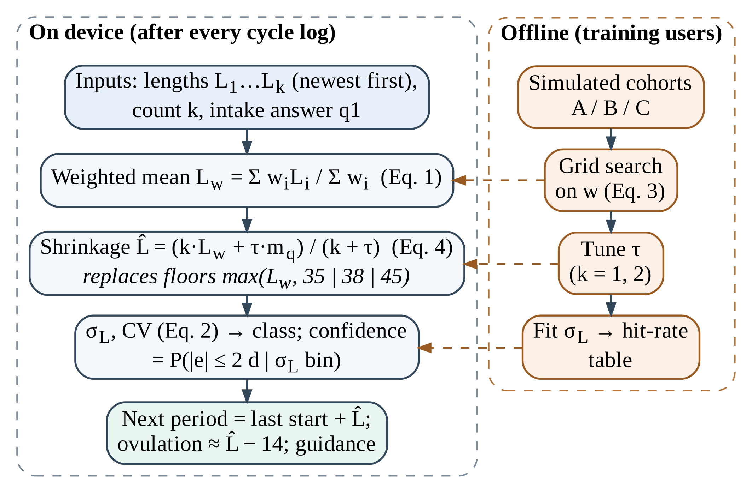
Figure 1. Forecasting path of SheSync with the proposed optimisation steps (left: on the device; right: offline, training users only).
3.2 Deployed Forecasting Engine
Logged period starts give cycle lengths L₁, L₂, … (most recent first), and the user states how many past cycles she recalls, k ∈ {1, …, 4} (Fig. 2b). The shipped function computes
L_{w} = Σ_{i=1..k} w_{i}L_{i} / Σ_{i=1..k} w_{i}, w = (3, 2, 1.5, 1) (1)
rounds it to whole days and then applies a hard limit from intake item q1 (Table 1). Dispersion and the coefficient of variation are
σ_{L} = [ (1/k) Σ_{i} (L_{i} − L̂)² ]^{1/2}, CV = 100 σ_{L} / max(20, L̂) (2)
with fixed values of 7.5, 4.2 or 1.2 days when only one cycle is known. A forecast is irregular if q1 is “irregular” or “absent”, σ_{L} > 5.5, CV > 18% or L̂ lies outside 21–36 days, and then shows max(65, 72 − round(1.2σ_{L}))%; moderate if q1 is “longer than 35 days”, σ_{L} > 2.5 or CV > 9%, showing max(76, 86 − round(1.5σ_{L}))%; and regular otherwise, showing min(97, 91 + min(2k, 6))%. The next period is placed L̂ days after the last start.
Table 1. Intake item q1, the hard limit of the deployed engine and the prior mean of the proposed estimator.
Answer to q1 (typical cycle) | Deployed rule | Prior mean m_{q} (d)
Consistent 26–30 days | none | 29
Shorter than 24 days | L̂ = min(L_{w}, 23) | 23
Longer than 35 days | L̂ = max(L_{w}, 38) | 40
Irregular or unpredictable | L̂ = max(L_{w}, 35) | 31
Absent for 90 days or more | L̂ = max(L_{w}, 45) | 45
Not answered | none | 29.3

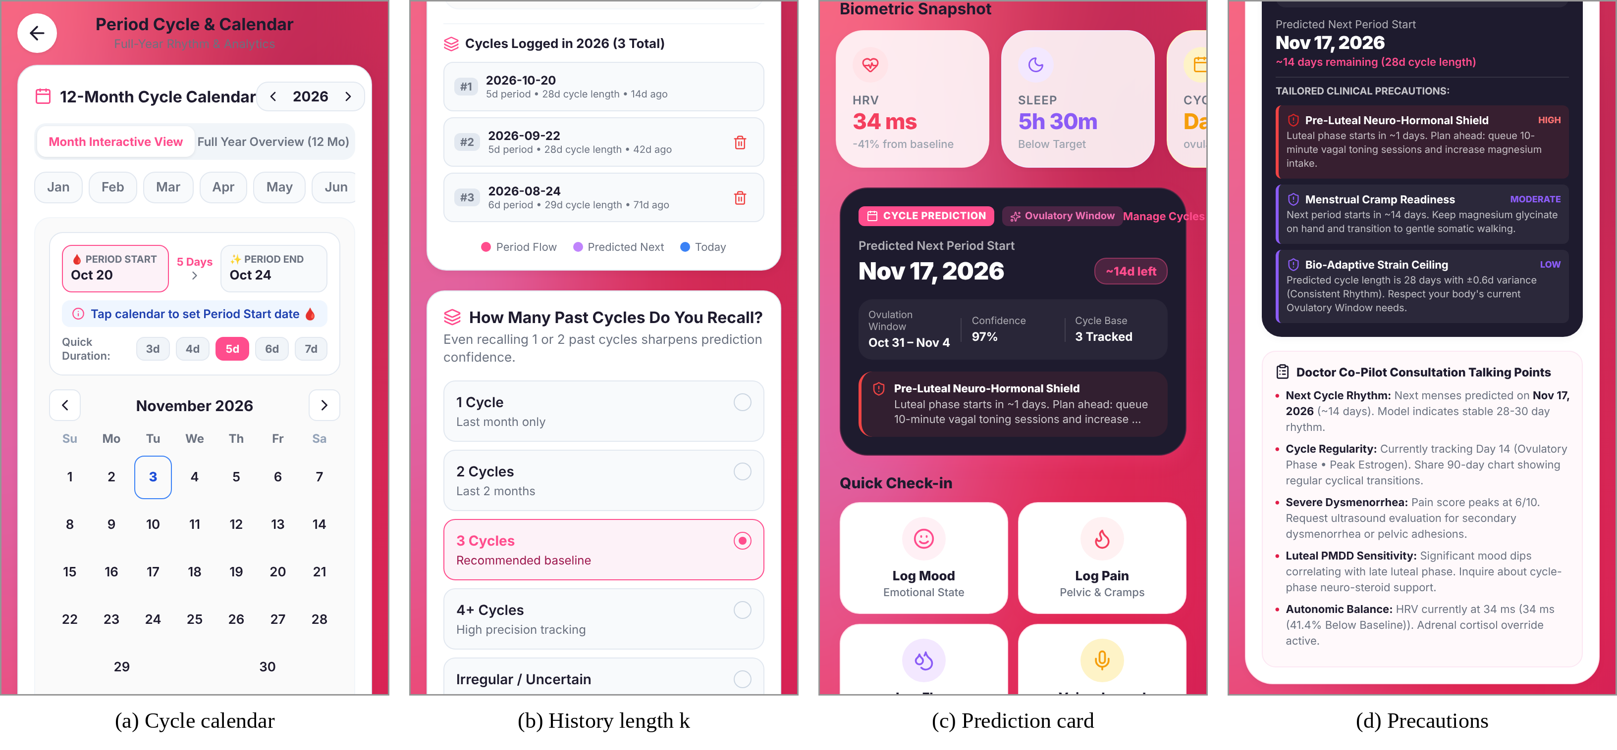
Figure 2. SheSync screens (production web build): (a) cycle calendar, (b) number of recalled cycles k, (c) prediction card with displayed confidence, (d) phase-specific precautions.
3.3 Weight Optimisation
Let H_{n} be the history before target cycle y_{n} in training task n. As only ratios of weights matter, w is normalised to the simplex Δ and
w* = arg min_{w ∈ Δ} (1/N) Σ_{n} | round(L_{w}(H_{n}; w)) − y_{n} | (3)
is the mean absolute error (MAE) of the forecast the user actually sees. Rounding makes it piecewise constant, so gradients vanish almost everywhere. Each un-normalised weight therefore takes one of nine values 0, 0.5, …, 4 (w₁ > 0), and the 6,561-point grid, which contains the deployed vector, is searched exhaustively; ties keep the first vector in lexicographic order. SES is tuned over α ∈ {0.05, 0.10, …, 0.95} on the same tasks as a reference.
3.4 Shrinkage Prior in Place of Hard Floors
A floor treats the questionnaire answer as certain and ignores the logged cycles, however many there are. The proposed estimator treats it as a prior with mean m_{q} (Table 1) and strength τ in equivalent cycles:
L̂ = (k·L_{w*} + τ·m_{q}) / (k + τ) (4)
With τ = 2 the prior carries two thirds of the weight after one cycle and one third after four, so the estimate moves from a population default to the user’s own history as data accumulate [15]. The prior means were fixed from published distributions [3, 8], and τ ∈ {0, 0.25, 0.5, 1, 1.5, 2, 3, 4} is chosen by training MAE on cold-start tasks (k = 1, 2).
3.5 Confidence Calibration
The displayed confidence is read as the probability that the period starts within two days of the predicted date, an event the user can check. Its frequency is estimated on training users in seven bins of σ_{L} (0–1, 1–2, 2–3, 3–4, 4–6, 6–8 and ≥ 8 days), and each test user is shown the value of her bin. Calibration is measured over ten confidence bins [18, 19]:
ECE = Σ_{b=1..10} (n_{b}/N) | conf_{b} − acc_{b} | (5)
3.6 Simulation Testbed and Protocol
As no consented user data were available, 1,000 users with 13 cycles each were simulated from parameters that follow published app data [3, 4, 12]:
L_{u,t} = round(μ_{u} + d_{u,t} + ε_{u,t} + δ_{u,t}), ε ~ N(0, σ_{u}²) (6)
where δ adds 5–14 days with probability p, and the drift d is zero (stationary regime) or a Gaussian random walk (drifting regime) [10, 11]. Table 2 lists the three cohorts. Each user answers q1 from her own profile (“longer than 35 days” if μ_{u} > 35, “irregular” if σ_{u} > 3.5 days, otherwise “consistent”). The pooled cycles have a mean of 32.7 days (SD 7.7), 75.3% lie within 21–35 days and 74.7% of users show a range of five days or more within six cycles, close to the app data cited above.
Table 2. Simulated cohorts and resulting cycle lengths (stationary regime).
Cohort | Users | μ_{u} (d) | σ_{u} (d) | p | Drift SD | Mean ± SD (d)
A regular | 400 | 28.8 ± 1.6 | 0.8–2.0 | 0.03 | 0.6 | 29.2 ± 2.7
B variable | 400 | 30.0 ± 2.2 | 2.5–5.0 | 0.10 | 1.0 | 30.9 ± 5.3
C long | 200 | 42.0 ± 5.0 | 4.5–9.0 | 0.12 | 1.5 | 43.3 ± 9.1

Users are split 50/50 with a fixed seed (20261103), and all constants are fitted on training users. For each test user, cycles 5–13 are forecast from the preceding four (4,500 forecasts per regime) or, at cold start, from the last one to three. Accuracy is reported as MAE, root mean squared error (RMSE), the share within ±2 days and the mean signed error (bias) [17], and the MAE reduction is bootstrapped over users (4,000 resamples) [21]. Before any comparison, the Python port was run against the original TypeScript function, bundled from the app source with esbuild and executed in Node.js v22, on 2,400 histories (k = 1–4) under each of the six q1 states.
RESULT AND DISCUSSION
4.1 Reproducibility and Forecast Accuracy
The port matched the TypeScript function in length, class, confidence and σ_{L} in all 14,400 cases, so the “deployed” results below describe the shipped code exactly. Table 3 and Fig. 3 report accuracy.
Table 3. Forecast accuracy on test users, stationary regime, k = 4 (4,500 forecasts).
Method | MAE (d) | RMSE (d) | ±2 d (%) | Bias (d)
Naive 28-day calendar | 5.92 | 9.15 | 42.1 | −4.79
Last cycle | 4.83 | 7.07 | 44.9 | −0.08
Mean of last 3 | 3.98 | 5.81 | 50.2 | −0.11
Median of last 4 | 3.86 | 5.70 | 52.7 | −0.11
SES (α = 0.35) | 3.92 | 5.73 | 51.2 | −0.11
Deployed weights only | 3.93 | 5.74 | 50.8 | −0.10
Deployed (weights + floors) | 4.20 | 5.99 | 47.9 | +1.13
Optimised weights | 3.88 | 5.68 | 51.1 | −0.11
Optimised + shrinkage (τ = 2) | 3.69 | 5.46 | 53.1 | −0.43

All history-based rules beat the 28-day calendar and differed little among themselves; the deployed weights alone (3.93 days) were within 0.1 day of the mean of three, the median of four and tuned SES. The floors made the engine worse than its own weighted mean, adding 0.27 days of error (6.9%) and a late bias of 1.1 days. The shrinkage estimator was best in both regimes (3.69 and 3.58 days) and raised the share within two days from 47.9% to 53.1%. The bootstrapped MAE reduction was 0.51 days (95% CI 0.41–0.60) for stationary and 0.36 days (0.26–0.47) for drifting cycles.
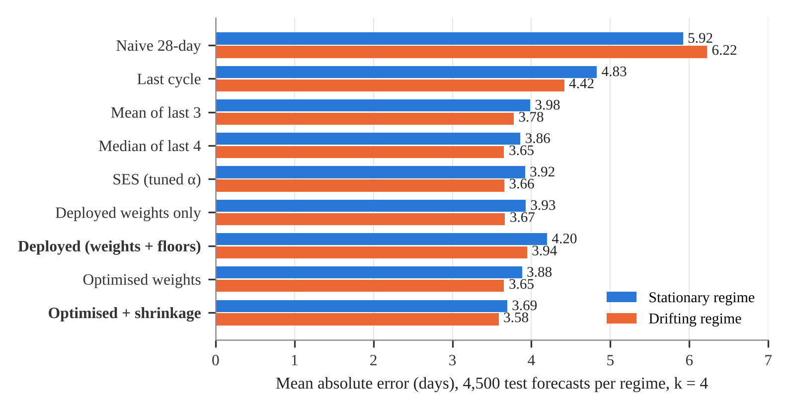
Figure 3. Mean absolute error of each method on test users, stationary and drifting regimes.
4.2 Where the Floors Hurt
For regular users (cohort A) the floors never apply. For the 128 test users who answered “irregular” but whose cycles averaged 31.0 days, the 35-day floor raised MAE from 4.66 to 5.84 days with a late bias of 4.2 days, an error that more logged cycles cannot remove because the floor is applied after averaging; shrinkage lowered it to 4.35 days. For long cycles (cohort C, mean 43.4 days) the 38-day floor helped slightly (7.29 to 7.13 days), and shrinkage kept that benefit (6.92 days). The pattern was the same under drift (irregular answer: 4.61 to 6.10 days with the floor, 4.43 with shrinkage).
4.3 Optimal Weights and the Value of Recency
The search took about 0.15 s per regime. The optimum depended on the regime (Table 4): older cycles were as informative as recent ones for stationary users, whereas drift favoured recent cycles, closer to the deployed weights. Re-tuning lowered MAE by only 1.2% and 0.3%, as the objective is flat near its minimum. Cohort-specific weights did not help either; for cohort C they were slightly worse on test users than the pooled weights (7.30 vs 7.22 days), a sign of over-fitting.
Table 4. Weight vectors (normalised) from exhaustive search on training users and their test MAE.
Weight vector | w₁ | w₂ | w₃ | w₄ | MAE (d)
Deployed (stationary / drift) | 0.40 | 0.27 | 0.20 | 0.13 | 3.93 / 3.67
Optimal, stationary | 0.20 | 0.24 | 0.28 | 0.28 | 3.88
Optimal, drifting | 0.32 | 0.28 | 0.20 | 0.20 | 3.65
Cohort A only, stationary | 0.24 | 0.24 | 0.28 | 0.24 | 1.66
Cohort B only, stationary | 0.30 | 0.19 | 0.26 | 0.26 | 4.30
Cohort C only, stationary | 0.20 | 0.24 | 0.24 | 0.32 | 7.30

To see when recency pays, the drift of all cohorts was scaled from 0 to 3 in an independent replicate (seed 777). Without drift the deployed weights were 0.04 day worse than equal weights; they broke even between scales 1 and 1.5 and gained 0.12 day at 3, where the optimum put 0.47 on the latest cycle (Fig. 4a). Recency weighting is thus a cheap bet on drifting cycles. The prior strength mattered mainly at cold start (Fig. 4b): with one cycle, MAE fell from 4.83 days at τ = 0 to 3.86 days at τ = 2.
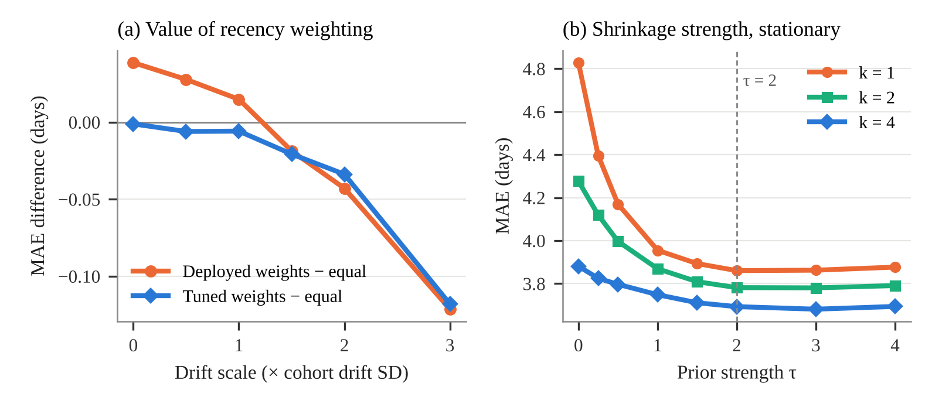
Figure 4. (a) MAE of deployed and re-optimised weights minus that of equal weights as drift grows. (b) MAE of the shrinkage estimator versus prior strength τ for k = 1, 2 and 4.
4.4 Cold Start and Confidence Calibration
With one past cycle the deployed engine erred by 4.84 days and the shrinkage estimator by 3.86 days, 20.3% less (13.2% under drift); the gap narrows but never closes, because a floor is never released (Fig. 5a). The displayed confidence was optimistic in every class (Fig. 5b): regular users saw 97% while 78.9% of their forecasts fell within two days, moderate users 80% against 45.8% and irregular users about 66% against 24.2%, an ECE of 31.6 points. Showing the training frequency of the user’s σ_{L} bin, from 82.6% below one day to 18.5% at eight days or more, cut the test ECE to 3.6 points (1.6 under drift).
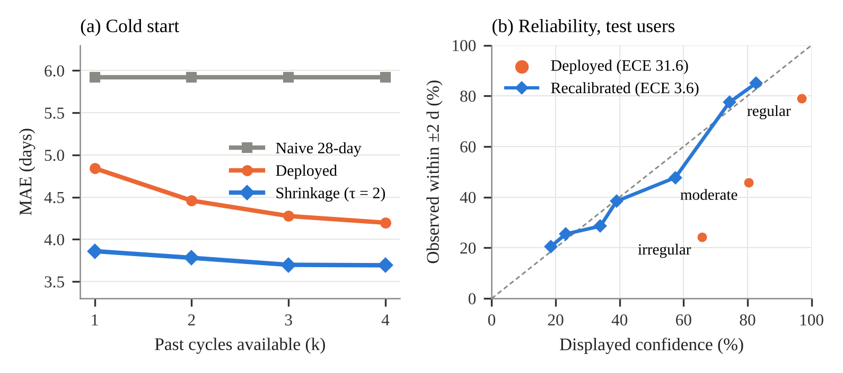
Figure 5. (a) MAE versus the number of past cycles. (b) Reliability diagram of the deployed classes and the recalibrated σ_{L} bins.
4.5 Implications and Limitations
The proposed engine uses only fixed constants, so it adds no measurable cost on the phone. For the app this means: replace the floors with the prior of Eq. (4), keep recency weights, and phrase the card as the chance of starting within two days. The evaluation is simulated; skipped logging [13], contraception, life stage and recall errors were not modelled, so the constants must be re-estimated on consented user data, and ovulation dates cannot be validated without hormonal or temperature markers [2].
CONCLUSION
Treating a small hand-written forecasting rule as an optimisation problem located its error: SheSync’s recency weights were already near optimal, whereas the hard questionnaire floors were the main avoidable error. A tuned shrinkage prior reduced the error by 9–12% overall and by about 20% at cold start, and a seven-entry table removed a 30-point overstatement of confidence, at constant cost on the device. Validation on consented user data is the next step.
Conflict of Interest
The authors declare no conflict of interest.
REFERENCES
- Epstein, D.A., Lee, N.B., Kang, J.H., Agapie, E., Schroeder, J., Pina, L.R., Fogarty, J., Kientz, J.A., & Munson, S.A. (2017). Examining menstrual tracking to inform the design of personal informatics tools. Proceedings of the 2017 CHI Conference on Human Factors in Computing Systems, 6876–6888.
- Worsfold, L., Marriott, L., Johnson, S., & Harper, J.C. (2021). Period tracker applications: What menstrual cycle information are they giving women? Women’s Health, 17, 17455065211049905.
- Bull, J.R., Rowland, S.P., Scherwitzl, E.B., Scherwitzl, R., Danielsson, K.G., & Harper, J. (2019). Real-world menstrual cycle characteristics of more than 600,000 menstrual cycles. npj Digital Medicine, 2, 83.
- Soumpasis, I., Grace, B., & Johnson, S. (2020). Real-life insights on menstrual cycles and ovulation using big data. Human Reproduction Open, 2020(2), hoaa011.
- Fehring, R.J., Schneider, M., & Raviele, K. (2006). Variability in the phases of the menstrual cycle. Journal of Obstetric, Gynecologic, & Neonatal Nursing, 35(3), 376–384.
- Bozdag, G., Mumusoglu, S., Zengin, D., Karabulut, E., & Yildiz, B.O. (2016). The prevalence and phenotypic features of polycystic ovary syndrome: A systematic review and meta-analysis. Human Reproduction, 31(12), 2841–2855.
- Moglia, M.L., Nguyen, H.V., Chyjek, K., Chen, K.T., & Castaño, P.M. (2016). Evaluation of smartphone menstrual cycle tracking applications using an adapted APPLICATIONS scoring system. Obstetrics & Gynecology, 127(6), 1153–1160.
- Munro, M.G., Critchley, H.O.D., Fraser, I.S., & FIGO Menstrual Disorders Committee. (2018). The two FIGO systems for normal and abnormal uterine bleeding symptoms and classification of causes of abnormal uterine bleeding in the reproductive years: 2018 revisions. International Journal of Gynecology & Obstetrics, 143(3), 393–408.
- Guo, Y., Manatunga, A.K., Chen, S., & Marcus, M. (2006). Modeling menstrual cycle length using a mixture distribution. Biostatistics, 7(1), 100–114.
- Bortot, P., Masarotto, G., & Scarpa, B. (2010). Sequential predictions of menstrual cycle lengths. Biostatistics, 11(4), 741–755.
- Oliveira, T., Bruinvels, G., Pedlar, C.R., & Newell, J. (2021). Modelling menstrual cycle length in athletes using state-space models. Scientific Reports, 11, 16972.
- Li, K., Urteaga, I., Wiggins, C.H., Druet, A., Shea, A., Vitzthum, V.J., & Elhadad, N. (2020). Characterizing physiological and symptomatic variation in menstrual cycles using self-tracked mobile-health data. npj Digital Medicine, 3, 79.
- Li, K., Urteaga, I., Shea, A., Vitzthum, V.J., Wiggins, C.H., & Elhadad, N. (2022). A predictive model for next cycle start date that accounts for adherence in menstrual self-tracking. Journal of the American Medical Informatics Association, 29(1), 3–11.
- Urteaga, I., Li, K., Shea, A., Vitzthum, V.J., Wiggins, C.H., & Elhadad, N. (2021). A generative modeling approach to calibrated predictions: A use case on menstrual cycle length prediction. Proceedings of Machine Learning Research, 149, 535–566.
- Efron, B., & Morris, C. (1975). Data analysis using Stein’s estimator and its generalizations. Journal of the American Statistical Association, 70(350), 311–319.
- Gardner, E.S., Jr. (2006). Exponential smoothing: The state of the art—Part II. International Journal of Forecasting, 22(4), 637–666.
- Hyndman, R.J., & Koehler, A.B. (2006). Another look at measures of forecast accuracy. International Journal of Forecasting, 22(4), 679–688.
- Naeini, M.P., Cooper, G.F., & Hauskrecht, M. (2015). Obtaining well calibrated probabilities using Bayesian binning. Proceedings of the AAAI Conference on Artificial Intelligence, 29(1), 2901–2907.
- Guo, C., Pleiss, G., Sun, Y., & Weinberger, K.Q. (2017). On calibration of modern neural networks. Proceedings of the 34th International Conference on Machine Learning, PMLR 70, 1321–1330.
- Bergstra, J., & Bengio, Y. (2012). Random search for hyper-parameter optimization. Journal of Machine Learning Research, 13, 281–305.
- Efron, B., & Tibshirani, R.J. (1993). An introduction to the bootstrap. Chapman & Hall/CRC.

*Address correspondence to vyomvarshney2005@gmail.com: Vyom Varshney, Department of Computer Science and Engineering (Artificial Intelligence), ABES Institute of Technology, Ghaziabad, Uttar Pradesh, India; Email Id-vyomvarshney2005@gmail.com

